Agenda 455/555 4.03.17 Mon.

* Firebasing!

[FirebaseNotify](https://firebase.google.com/docs/notifications/?utm_source=studio) app ref: chapters 51 - 52

Send + Receive notifcations (messages, data, etc.)

What’s inside?

1. Run app
2. Go to Tools > Firebase
3. Select Notifications from Firebase Assistant

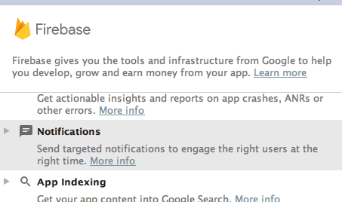

Click on Receive Notifications in your app link

1. Go through steps (be logged into your Google email account)

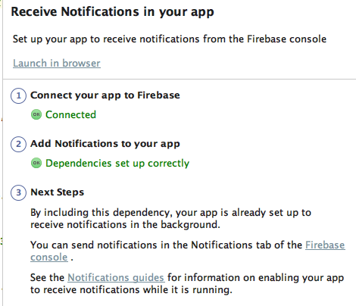

At your third step click on the Firebase console link to point to your project you set up thru your app.

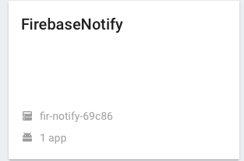

Find link to Compose a message and enter in desired data fo push a message to a device loaded with your app! Check the Advanced option as well for sending even data to the app.

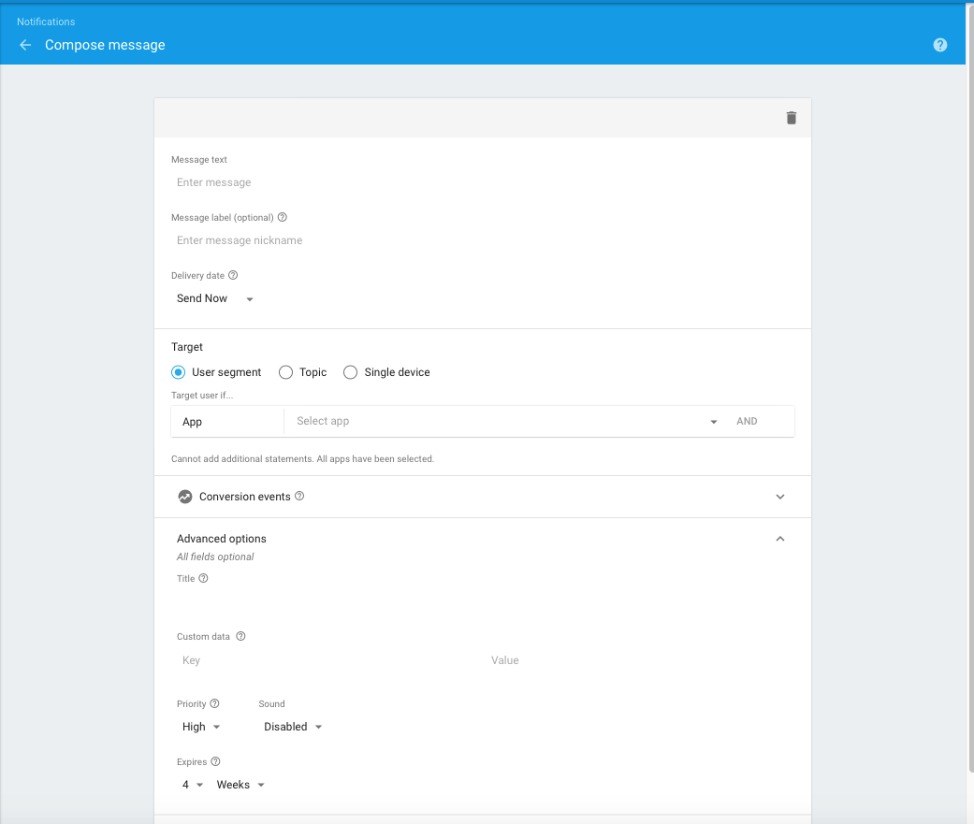

Key / Value pairing

Other links to ponder:

<https://console.firebase.google.com/?pli=1>

<https://firebase.google.com/docs/cloud-messaging/>

<https://firebase.google.com/docs/cloud-messaging/android/client>

<https://developers.google.com/cloud-messaging/http> (using papaserver as xmpp server??)

Firebase Realtime Database for tracking???  (uses json for storage, + nosql?)

<https://firebase.google.com/docs/database/>

<http://www.androidhive.info/2016/10/android-working-with-firebase-realtime-database/>

<https://www.raywenderlich.com/139322/firebase-tutorial-getting-started-2>

* Lab 7 discussion- GUI logic, SQLite Manager, SQLite from the CLI revisted!